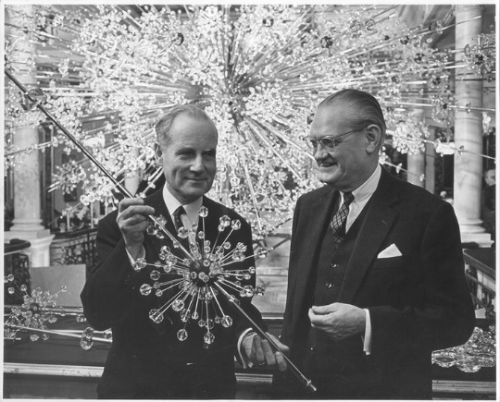

Lobmeyr

Method & Concept is proud to present Lobmeyr Lighting from Austria, producers of some of the world’s finest glass and crystal products for nearly 200 years.
Lobmeyr is in its sixth generation as a family business. A love of the material, the emotional relationship with the product and the commitment of personal energy defined their method of working from the beginning. Its rich history began with its 1823 founding by Josef Lobmeyr Sr. in Vienna’s Weihburggasse and for two centuries, each generation leaves its own iconic trace with highlights including the first use of the electronic chandelier in 1883 as well as the first use of Swarovski crystal in a chandelier in the 1950s.
Though Lobmeyr continually focuses on the contemporary interpretation of glass, it has never stopped cultivating its heritage. The old inspires the new and traditional know-how facilitates innovation.
Method & Concept’s Lobeymr collection is currently on view and available in Naples, Florida.
Please Inquire with Method & Concept: info@methodandconcept.com
