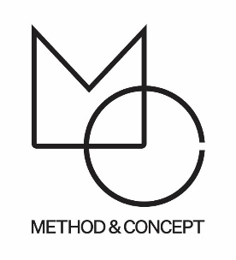

Luke Lamp

Method & Concept is proud to represent Luke Lamp!
Luke, the designer, and founder of Luke Lamp Co. rediscovered some vintage industrial light fixtures in 2011 while wandering around at an abandoned railcar plant in New Hampshire. After bringing them home, rewiring them, and spending several weeks shooting pictures and creating a website he published them on the internet.
The next thing he knew, his work was published on one of the largest sites dedicated to interior design, and they quickly sold out of everything. After receiving a sudden flood of real-life consumers from all over the world, he entered the fascinating field of lighting design and never looked back.

Method & Concept’s Luke Lamp collection is currently on view and available in Naples, Florida.
Please Inquire with Method & Concept: info@methodandconcept.com
