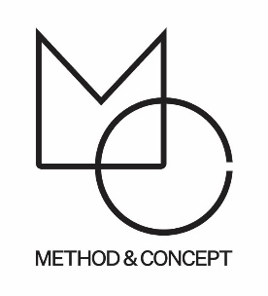
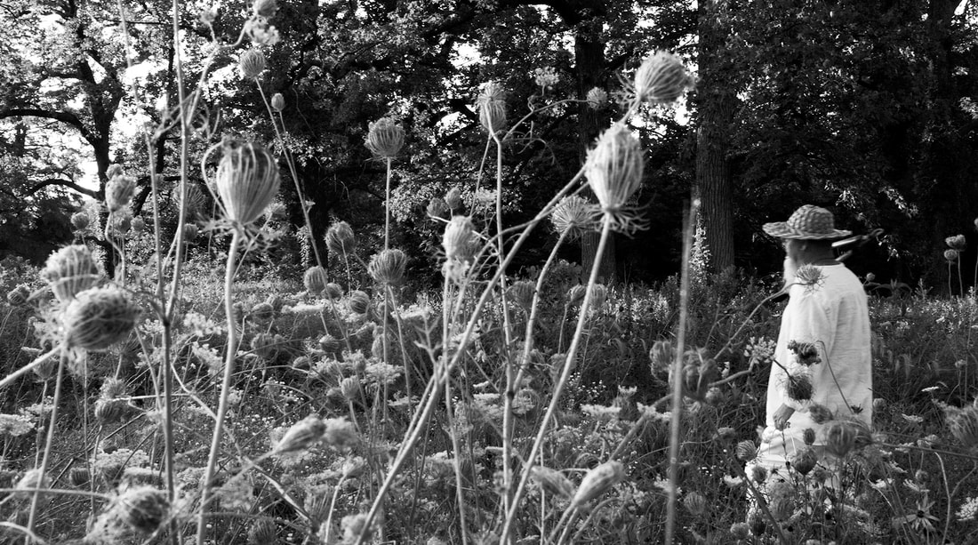
Ran Adler

Drawn to Nature’s roughness, randomness and disorder, Ran Adler takes a meditative approach to life and his art. His gathering of organic materials (while wandering such places as along the banks of the Mississippi River) is the inspirational first step. Ran’s rhythmic, repetitive process of sorting, cutting, weaving, threading, burning, and inscribing induces a prayer-like state and clarifies his intention...to share the harmonious transformation of chaos into order. His purpose is achieved through his iconic assemblages.

Please Inquire with Method & Concept: info@methodandconcept.com

