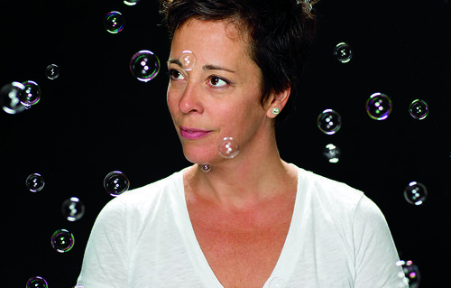
Ysabel LeMay

Quebec born Ysabel LeMay’s describes her practice as a “journey into simplicity.” In 1987, she began a thriving career as a graphic artist working for several prominent advertising agencies before opening her own firm in Vancouver, B.C. Seeking greater fulfillment, she transitioned into fine arts studying painting at the Emily Carr University of Art. In 2002, she left the world of corporate advertising behind devoting full-time to her painting. Since then, she has achieved much success with over 40 exhibitions throughout the United States, Europe and Canada.
In 2010, LeMay turned her full attention to photography. Combining her technical expertise with her deep-seated roots as a painter, LeMay continues her focus on the power and divinity of nature through a unique process she calls “Photo-Fusion” – at first glance, you might think you are looking at a hyper-realistic painting. LeMay’s innovative technique is a lengthy process utilizing hundreds of photographs while manipulating light and visual properties. Her final piece is a painstaking assemblage of multiple details to form a larger individual composition.
In 2011, LeMay was declared winner of KiptonArt Rising Star program in New York and has exhibited all over the US, Canada, Europe and The Netherlands.
She travels extensively as a part of her process and lives and works in Austin, Texas.

